AWS Environment

## EC2 List of running servers.

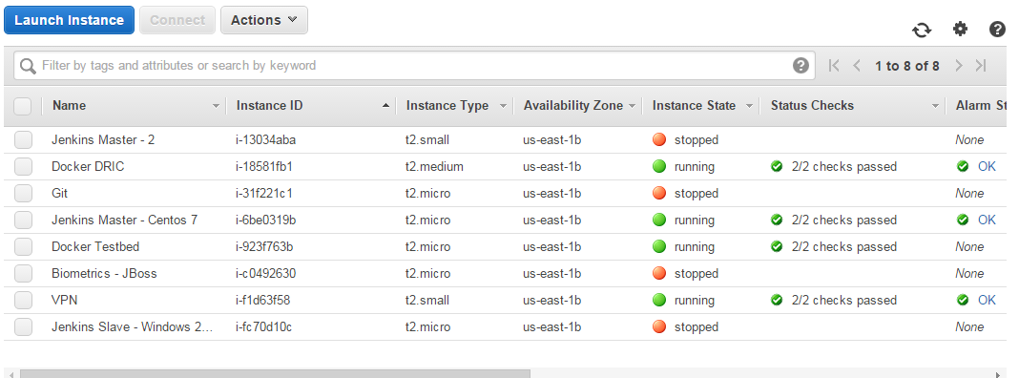

## Security Group for EC2s

**VPN (**i-f1d63f58**)**

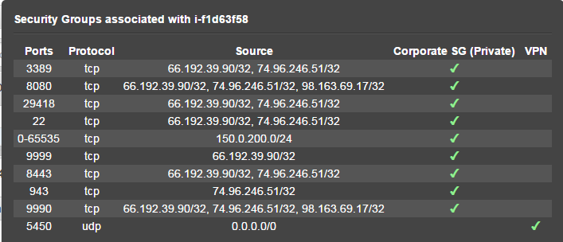

**Docker DRIC (**i-18581fb1**)**

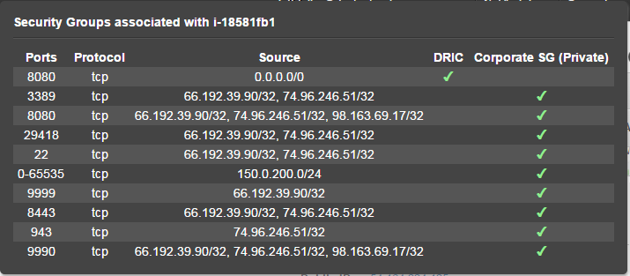

**Jenkins Master – Centos 7 (**i-6be0319b)

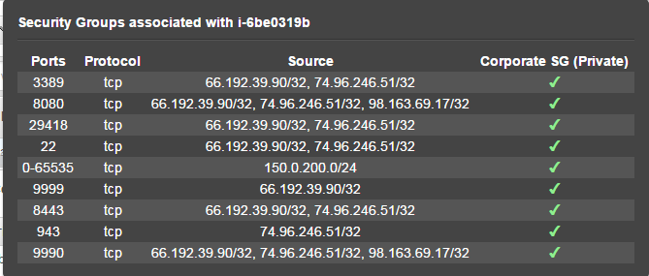

## VPC

Private Corporate US East 1b: vpc-9c1350f9

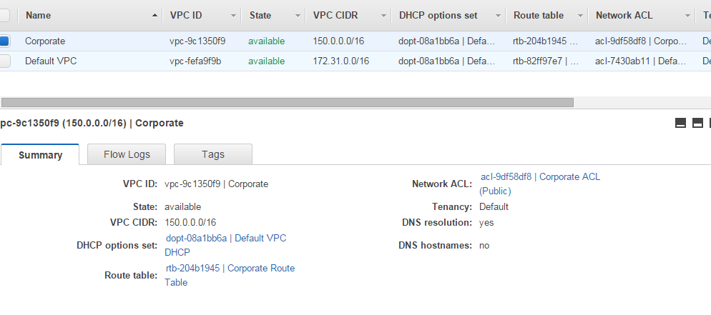

**Elastic IPs**

